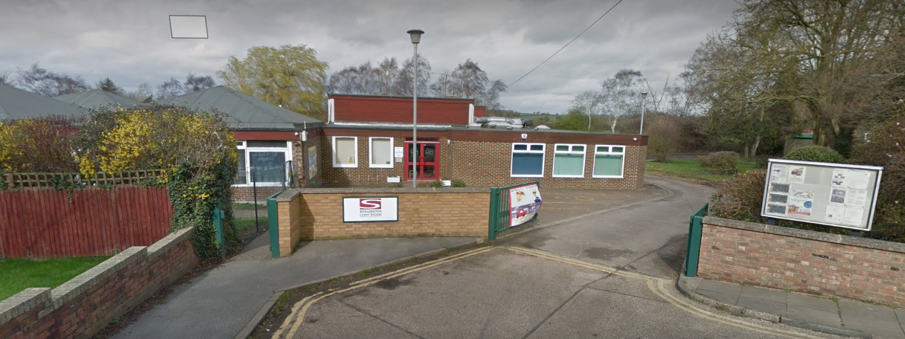
Welcome to
Shillington Lower School


Shillington Lower School
Value everyone, Value every chance, Value every day

Greenfields
Shillington
Nr Hitchin. SG5 3NX
01462 711637
office@shillingtonlower.co.uk
www.shillingtonstondon.co.uk
Prospectus 2025-2026
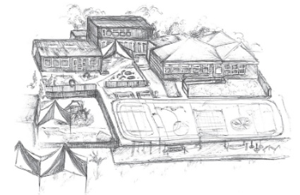

Welcome to our School
Dear Parent/Carer
I welcome you to Shillington Lower School on behalf of the staff, the children, the parents, and the governors.
It is our belief that everyone deserves the best life chances and that our school, in partnership with parents and carers, plays a vital role in that. We aim to promote a child's curiosity about the world around them, foster an irresistible love of learning, develop their independence and social awareness, and promote lifelong positive learning behaviours. Our school motto "Value everyone, Value every chance, Value every day" captures this belief and sits alongside our Vision and Aims for the school.

From the moment the children first arrive, we aim to help them to settle quickly, build excellent relationships with other children and with adults, feel happy, safe and secure and quickly take those first steps on the next phase of their learning journey.

Shillington Lower school is federated with Stondon Lower school in a Hard Federation with one Governing Board. From January 2026 each school will have their own Head teacher. At Shillington we will be welcoming Mrs Sarah Flack.

Shillington Lower School has a developing, committed, and passionate staff team and Governing Body who work closely together to provide a positive environment and experience that meets the needs of all pupils. We are actively supported by a dedicated parent and teacher and friends’ association (PTFA).

We work closely with community members including All Saints Church and the Congregational Church.
Shillington Lower is a Values school of which we are all very proud.


Looking forward to welcoming you very soon,
Miss Sarah Woodham
Headteacher

Our School
Shillington Lower School is a Central Bedfordshire Local Authority School. Responsibility for its management is delegated to governors, all of whom have a direct interest in education and links with the local community.
Our school is situated in this historically fascinating village, with beautiful countryside all around and with its various hamlets and a parish church that may date back 1000 years. Our school educates children from the age of two to nine years old, drawing children from surrounding villages.
A large number of our children transfer from our own on-site Pre School. They progress mainly to Robert Bloomfield Academy and, from there, Samuel Whitbread Upper School.
We are a school with a values ethos which means we teach and model the values we believe we all need in life. Please support our values programme by always modelling the values to your child.
Our core values are respect, kindness, honesty, friendship, perseverance and self-belief.

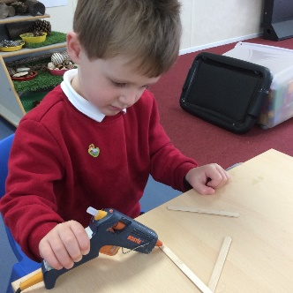
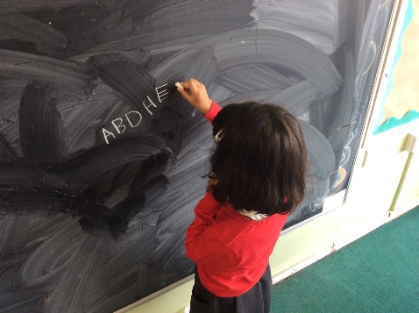

Our Vision
We will provide a broad and balanced curriculum rich in key skills and experiences which develops each child as an independent learner
We will create a happy, safe, and stimulating learning environment where the children feel safe, nurtured and are inspired to achieve their potential
We will be an outward facing school drawing from the valuable knowledge, experience and life skills from our stakeholders, local community and from our environment
We will teach children the importance of using and showing values and applying these in all aspects of their life
We are welcoming without exception, we take pride in similarities and differences, whatever they are
We will empower our children to be curious, adventurous, innovative, independent learners who are ambitious for themselves and each other. We want them to maximise every opportunity, overcome challenges and fulfill their potential as responsible citizens.
We will provide a balanced framework of academic and holistic support to create and nurture the physical and emotional wellbeing of everyone.

CURRICULUM
We aim to provide an inclusive curriculum where children receive quality in their education regardless of race, gender, or religion. Our teaching follows the National Curriculum and the Bedfordshire Agreed Syllabus for Religious Education.

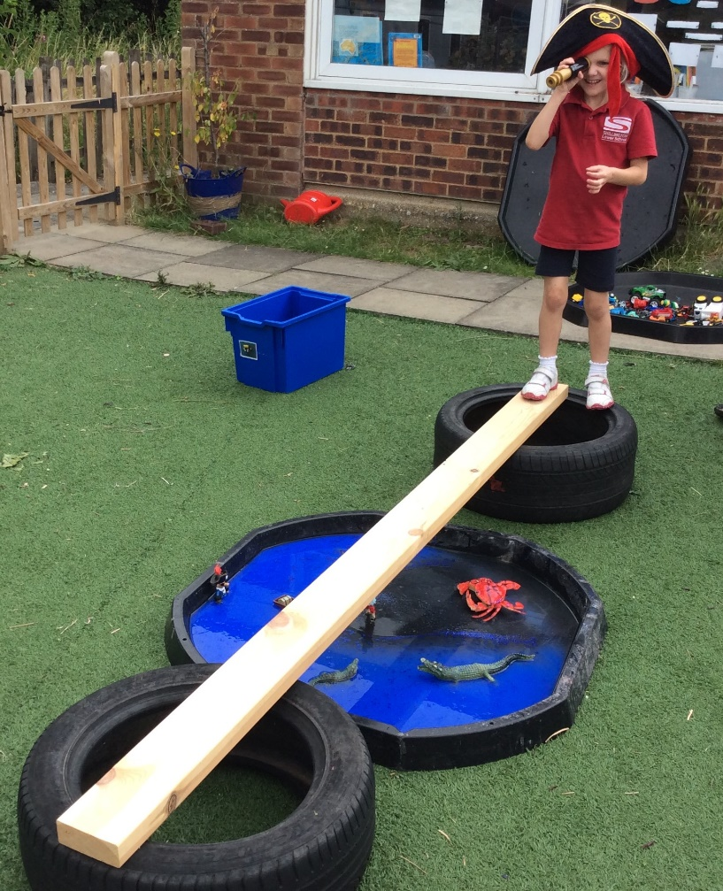
Our teaching methods are designed to encourage the development of confidence, independence, and responsibility. A variety of strategies are used to enable children to learn effectively. These include individual, group and whole class teaching. We provide a broad and balanced education. Pixies pre-school and Hedgehogs (Reception) Foundation follow the Early Years Foundation Stage Curriculum.

The National Curriculum
This comprises of eleven subjects, together with Religious Education and also Personal, Social, Health Education (PSHE).
Core subjects: English, Mathematics, Science and Computing.
Foundation subjects: Art & Design, Design Technology, History, Geography, Modern Foreign Language (e.g., French), Music, Physical Education, PSHE.

ENGLISH
This is very evidently fundamental to all learning and given high priority. The majority of our skills taught include speaking and listening, reading, writing, punctuation, spelling and grammar and handwriting. Parents are provided with information sessions to help understand support their children’s Phonics work. We also ensure that parents are enabled to understand the carefully stepped programmes for developing reading skills followed at Shillington. All children are given a home school book and should read with their parents regularly.
Writing is also taught in a carefully programmed way – from the correct way to hold a pencil through to well-presented cursive writing. Children will develop their skills in storytelling and other forms of writing.

MATHEMATICS
As with English, engaging parents in how skills, techniques and understanding Mathematics are taught is very important. There are a range of ways in which pupils learn their Maths which have moved on significantly in recent years. At the same time the intent to linking this study to practical applications and to developing a sense of the fun and interest that can be
had in this subject is very important.

ORGANISATION OF CLASSES
Our classes are mixed ability. The teaching organisation of each class will vary according to the activity. Children are often taught as a class, sometimes in a group and sometimes individually. Sometimes they will be grouped within the class by ability and at other times the organisation will be to mix abilities.
In our school we have the following classes:
 | Class Name | Year Group | Age Range | Teacher
Pre-School | Pixies |  | 2 - 4 | Miss McMunagle, Miss Meredith and Miss Lucy McGrath
Foundation/key stage 1 | Hedgehogs | Reception | Age 4-5 | Mrs Hanlon
Key  Stage 1 | Squirrels | Year 1/ Year 2 | Age 5-7 | Miss McBarron
Key  Stage 2 | Rabbits | Year 3 | Age 7-8 | Miss Gradwell
Key  Stage 2 | Barn Owls | Year 4 | Age 8-9 | Mrs Mossop
Staying in touch
A successful school like ours is built on a great working partnership with our children’s families and carers. We have a range of ways to keep in touch regularly with you.

We greet the children at the school gate every morning and in the afternoon either the class teacher or teaching assistant will see the children to the school gate and hand over in person to parent/family.
Every child has a home school diary in which both parents and teachers can write positive comments and messages. This diary is the most important way we have of communication between school and home.

We use ParentMail regularly to communicate with our families. Every fortnight we email our newsletter to report what has been happening in school and advise of events and issues for the coming weeks.

Twice a year parent consultation evenings are offered with a range of times across the days in order to maximise the options for parents.

SEND
At Shillington Lower School we believe in giving everyone, every chance, every day to achieve his or her full potential in all aspects of school life, through a varied curriculum that is rich and challenging. We aim to raise the aspirations, and expectations for all pupils regardless of gender, race or ability.
Our Special Educational Needs and Disability Policy follows the National Code of Practice for Special Educational Needs. We work closely with parents to ensure that every child makes good progress. Children with identified Special needs will have a provision plan which will be reviewed every term.
A copy of our SEND policy is available on request or on the school website.
The school SENDCo is Mrs Nicola Foxall.

SCHOOL DAY
Years 1, 2, 3, 4
8.45 am The school gate is open, and children go directly to class
9.00 am Gate closes and morning session begins
10:30-10.45 am Morning break key stage 1
10:45-11:00 am Morning break key stage 2
12:00– 1:00 Lunchtime
1:00 Afternoon session begins
2:15 – 2:30pm Afternoon break (Years 1 and 2)
3:30 pm School day ends- parents collect from the playground

Reception
8:45 am Parents bring their children to the area outside the Hedgehogs classroom.
11:45 – 1:00 pm Lunch.
3:30 pm Parents collect their children from the classroom door.
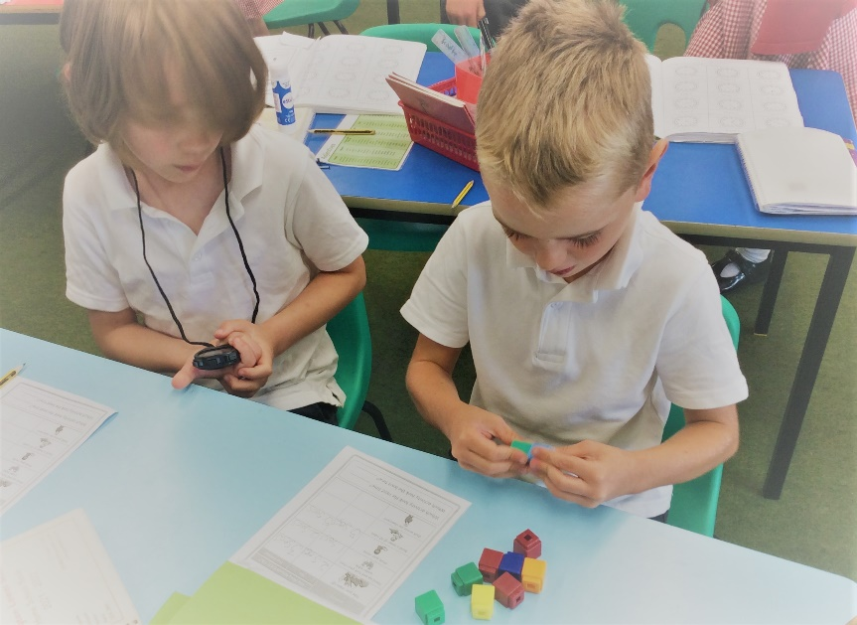
In Hedgehog reception class, morning and afternoon break-times vary and children have access to the outside play area at most times of the day.

All children should be in school by 9.00 am. Children arriving between 9am & 9.30am are coded as late, those arriving after 930am are coded as late after the register has closed, this affects your child’s overall attendance.

Children will be dismissed at 3.30 pm. The children are escorted to the playground and are only released to a named responsible adult.

Please note: for all children, we understand that occasionally parents are unexpectedly delayed at the end of the school day. If you are delayed, please contact the school on 01462-711637 as soon as possible so a message can be given to your child’s teacher and inform us of alternative collection arrangements.

If you have made alternative arrangements for your child’s collection (e.g., going home with another parent, going to a friend’s house etc.) the school must be informed via the home/school communication book, phone, or letter on that day as to who will be responsible for their safe collection. In line with our safeguarding policy, we cannot release a child unless this permission has been given.

OFSTED 2023

Shillington Lower was inspected by Ofsted on 3rd and 4th July 2023 and continues to be a GOOD school is all categories.

The Inspector commented on the fact that “pupils take pride in their achievements.” “Pupils behave well and have positive attitudes to learning.”

Reading is the most important skill that children should develop at school and our inspectors noted that “Pupils enjoy reading and choosing books from the school library, they talk enthusiastically about them and like discussion the moral dilemmas”.

At Shillington, staff care deeply about helping the children to achieve their best. We are extremely proud of our offer to pupils, and this was reflected in her comment, “Pupils with SEND are well supported”.

Personal development and safeguarding were also key strengths, “Staff support pupils’ personal development well.” “ Pupils know it is important to listen to the views of others and to respect others’ differences” and “arrangements for safeguarding are effective” Another strength of the school as highlighted by the Inspectors is our values ethos, PSHE curriculum and how well our pupils behave “Pupils say they know who to go to if they have a worry and that bullying is rare” “Parents and pupils are confident that if bullying does occur, leaders deal with it effectively.

THE GOVERNING BOARD
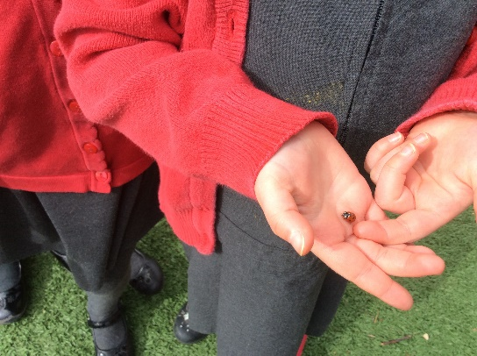
Governors are appointed, elected, or co-opted for a fixed term. The Governing Board is made up of representatives from the staff, parents, community, and members nominated by the local authority. The Headteacher is also a Governor.

The Governing Board supports, guides, and works in partnership with the Headteacher to focus on the school’s strategy for excellence and continuous improvement. Our Governing Board is comprised of a diverse group of local people with a range of experiences and expertise. The full Governing Board meets at least four times a year with much of the work being carried out in termly sub-committee meetings. These include:
- Resources and Planning Committee which oversees finance, staffing issues and the overall development and forward planning of the school
- Standards, Teaching and learning Committee which meets to discuss aspects
of what is taught in school and results

We have an active governing board who work closely with the Headteacher and staff and their responsibilities include:
- the general conduct of the school;
- the appointment of staff;
- the school environment;
- the welfare of the children and staff;
- the curriculum;
- setting and monitoring the school’s budget;
- contributing to the School Development Plan; and
- monitoring the overall effectiveness of the school.

Our Chair of Governors is Kirsty Whitehead, who can be contacted via the school office.

ADMISSIONS
Complaints Procedure
The school aims to work closely with parents, and we hope that parents who have any concerns or anxieties will, in the first instance, raise these with the class teacher.
The governors of the school do have arrangements and a complaints policy for considering complaints formally. For general complaints and matters concerning special needs they have adopted a procedure which follows guidelines recommend by Central Bedfordshire Council.

Central Bedfordshire Council operates a catchment area policy although parents have the right to express a preference for another school. At Shillington Lower School we welcome applications from outside our catchment area.

The maximum capacity of our main school is 150 pupils, and we are able to admit up to 30 pupils in any one year group. If the number of places in a particular year group at a school is not sufficient to meet the requests of all parents, then the local authority will apply the following criteria (in the rank order shown) to determine how the places will be allocated:

- All ‘looked after’ children or children who were previously ‘looked after’
- Children living in the catchment area with siblings at the school
- Children living in the catchment area
- Other children with siblings at the school
- Children who live nearest to the school determined by straight line distance from the school site to the child’s home address

Children enter the main school in reception class the school year in which they turn five.
They enter the Foundation Stage class in one intake in September.
The preschool is open for children from the term in which they become 2 years 9 months.

We welcome visits to the school from prospective parents. The Headteacher is always willing to discuss any aspects of school with you. Parents are asked to telephone the school office to make an appointment for a meeting at a mutually convenient date and time. Once you have decided that you wish your child to attend Shillington Lower School, please inform the school office who will guide you through the admissions process.

Further information on how to apply for a school place is available on the Central Bedfordshire Council website at;
http://www.centralbedfordshire.gov.uk/school/admissions/landing.aspx
The School Admissions Service can be contacted on 0300 300 8037 or admissions@centralbedfordshire.gov.uk

Further details of our admissions policy are available from the school office.

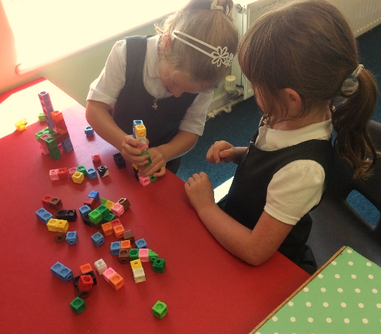
Transfer to the next stage of education
At Shillington, most children transfer to Robert Bloomfield Academy in Shefford, although some choose to transfer to Year 5 classes at local primary schools.
There is a close liaison with Robert Bloomfield Academy throughout Year 4 to ensure transition is an enjoyable and exciting experience.
UNIFORM

Children should be sent to school clean, tidy and appropriately dressed.
Long hair must be tied back.
It is of great help if children have been taught to manage buttons, laces and zips before starting school.

Uniform:
White polo shirt - school branded or plain
Red sweatshirt/cardigan - school branded or plain
Grey trousers/shorts
Grey skirt/grey pinafore/red gingham summer dress
Black school shoes - worn all year round
White/grey/red or black socks/tights

Footwear
Sensible dark coloured shoes are preferred for both boys and girls. Trainers and open-toed sandals are not suitable.
Children in Hedgehogs and Pixies are also required to have a pair of Wellington boots in school. These should be clearly named.

PE

On days when children have PE they come to school in their PE kits

PE kit is black shorts, red short sleeved t-shirt with or without school logo and trainers. Dark tracksuit bottoms and top.

For more information, please see the school's uniform policy which is on the website.

Our uniform provider is
My Clothing
https://myclothing.com/collections/shillington-lower-school-pupil-uniform-21092

PLEASE ENSURE ALL CLOTHING AND BELONGINGS ARE NAMED.

SCHOOL POLICIES

SEND Policy (Special Educational Needs and Disabilities)
Our Special Educational Needs Policy follows the assessment stages in the National Code of Practice for Special Educational Needs and Disabilities. We work closely with parents from the early identification stage of any child experiencing learning difficulties and respond sensitively and professionally to differences in learning abilities.
Lessons are planned to provide work of the appropriate level for our children. All children are given work that ensures they are properly stretched and challenged.
This policy is available on our website.

Promoting Positive Behaviour Policy
Our children are considerate, polite, excellently behaved and enjoy school greatly.
Children are expected to behave well and treat everyone with the same respect. We promote good behaviour and attitudes to learning by recognising, drawing attention to and rewarding this high standard of behaviour.

In cases where a child’s behaviour causes concern, parents are contacted and together we discuss and work towards resolving the issues. All staff and children follow the school’s policy on discipline/behaviour which also encompasses the issue of bullying. Visual reminders are displayed in each of the classrooms and at other prominent places around the school.

Safeguarding
We are committed to the safety of all our pupils and make positive steps to ensure we actively promote and adhere to safeguarding principles and policies.
We expect parents, families, and visitors to also actively support this commitment and respond to guidance and direction regarding key routines we have for safeguarding the children in our care.

Copies of school policies are available from the school office and on the school website.
School Meals

School meals are prepared, cooked and served on the premises. Children have choices and variety each day. Facilities are available for children who bring a packed lunch.
Shillington Lower School is a ‘Nut Free Zone’.
Please do not include nuts of any kind in your
child’s lunch box or any snacks.

Universal free school meals are offered to all children in Foundation Stage, Years 1 and 2.
Some families throughout the school may also be eligible free school meals and this brings in additional funding to the school (known as Pupil Premium) – you may be eligible if you are in receipt of government benefits. The school office can advise on this.

As a school, we legally have to make milk available to children during the school day. We do this through a company called “Cool Milk.” Parents contact the company directly. Please ask the office for further details

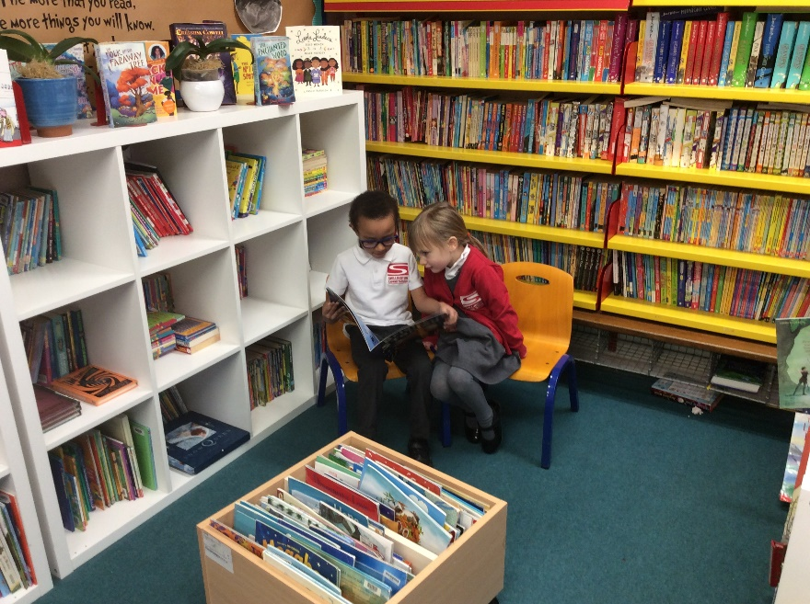
Healthy Schools
We are proud of our Healthy Schools accreditation. The whole school worked together to achieve this award. All children are encouraged to drink water throughout the day and keep a personal water bottle in their classroom. These can be purchased from the school office.

If your child is in Reception or years 1 or 2, he/she will be given a free piece of fruit or vegetable every day. This is usually provided before the morning break. Children in other classes are allowed to bring fruit or vegetables for mid-morning break.

NO NUTS, CANS OR FIZZY DRINKS ARE ALLOWED IN SCHOOL

School Council
The School Council is a representative group of children who have been elected by their peers to represent their views and raise issues with the Staff and Governors.

They have many roles within the school. They:

- Help to raise awareness of charities and raise money for them in a variety of ways
- Read and address suggestions made by other children or staff
- Prepare and lead assemblies

We also offer other leadership opportunities in year 4 with various roles.

Helping in School

There are many areas of life in school which would be almost impossible without the help of parents/carers and other volunteers. We are most grateful for all the help we receive, whether it is on a regular or occasional basis. Regular help covers such things as helping with art and craft, sewing, technology, cooking, reading with the children and gardening. In order to become a helper in school, volunteers will have to undergo an enhanced disclosure clearance from the Disclosure and Barring Service, specifically for helping at Shillington Lower School. If you would like to volunteer to help in school, then please contact the school office.

Community Links

We are extremely fortunate to have a large number of volunteers who come into school to help with such things as reading and school trips.

We have good links with the local community, with the Congregational and Church of England ministers regularly leading assemblies. One of our aims is to develop further links with the local community.

Collective Worship

Whilst not a church school, Shillington has a Christian ethos. The majority of assemblies are broadly Christian in character, with some drawing on other faiths and traditions.

Parent Teacher and Friends Association
Every parent at Shillington Lower is a member of the PTFA – the Parent Teacher and Friends Association. We have a dedicated group of parents who work relentlessly to organise a range of activities to raise money for the school. Events have included school discos, Christmas Fayre, after school lolly and cake sales and pre-loved uniform sales, Santa's fun run and Santa's shop.

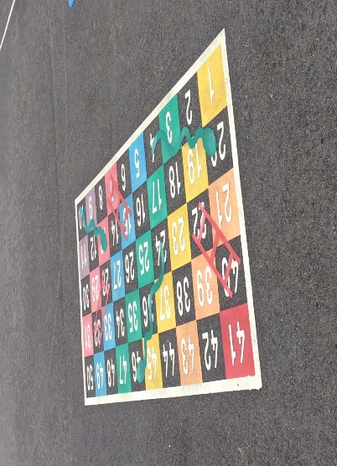
Every year the PTFA funds different projects in school. It also donates money to each class for additional resources and enrichment activities. If you would like to volunteer to join the committee or would like further information on the PTFA please contact the Chair via the school office.
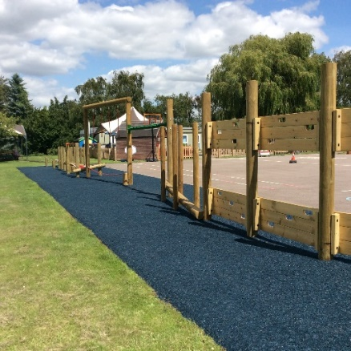
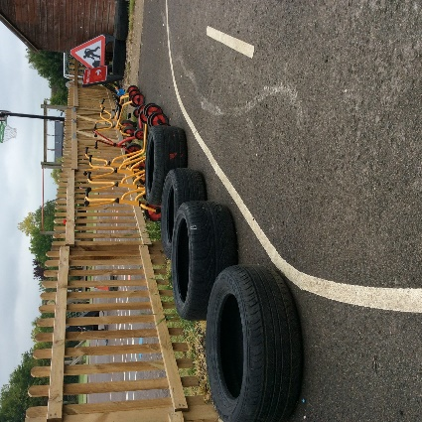

.
Pupil Premium
What is the Pupil Premium? The Pupil Premium was introduced in April 2011 and is additional funding that the government gives to schools for each pupil on roll where their parent(s) are in receipt of any of the following: · Income support
· Income-based Jobseeker's Allowance
· Income-related Employment & Support Allowance
· Support under Part VI of the Immigration & Asylum Act 1999
· The guaranteed element of State Pension Credit
· Child Tax Credit (provided you are not also entitled to Working Tax Credit and your annual gross income does not exceed £16190)
· Working Tax Credit run on (paid for 4 weeks after you stop qualifying for Working Tax Credit)
· Universal Credit (if applying after 04/2018 you must have an annual net earned income of no more than £7400, after tax and not including any benefits you get)

The money must be spent on that pupil to support their education, but it is for the school to determine how it is spent.
If you think that you meet the free school meals eligibility criteria, please call Central Bedfordshire Council on 0300 300 8306. When you call, please have the following information available:
· National Insurance Number
· Date of birth for your child/ren
If you need any further assistance or have any questions, then please do not hesitate to contact the school office.

Medicines
Parents should endeavour to ensure that, where possible, medicines prescribed by the GP/hospital can be administered before and after school, thus, making it unnecessary for school staff to administer medicines during the school day. We will only be able to administer medicine at school if it has been prescribed to be taken 4 times per day. If this is the case then we will ask you to complete an “administering of medicines” form, available from the school office. This must be completed by a parent on the first day the medicine is required.
Non-prescription drugs/medication cannot be administered and should not be sent into school.

If your child has asthma and requires an inhaler to remain in school, then please let us know.

Accidents and First Aid
Parents are contacted when children are ill or have anything other than a minor injury. Parents are also informed if children receive an injury which gives cause for concern. If parents are unobtainable, further medical advice will be sought, if it is felt appropriate.
The local authority’s recommended procedure for first aid is to simply wash and, if necessary, cover cuts and grazes. It is vital for parents to keep the school informed of any changes in medical conditions and emergency contact telephone numbers.

