MFL (French) is taught to all pupils in Key Stage two following the KAPOW Primary Mixed-Age Planning.

Intent
Curriculum Aims
Shillington Lower School aims to inspire pupils to become curious, confident and enthusiastic language learners with a broad understanding of the French language and culture; in other words, to think and communicate like linguists. The intention is for pupils to develop the skills to listen, speak, read and write in French, while building the confidence to express themselves and explore new ways of thinking through language learning.
The scheme is designed to develop pupils’ understanding of how learning another language connects people, cultures, and communities worldwide. The aim is to encourage pupils to become open-minded, active citizens who can appreciate diversity and engage meaningfully with the wider world.
Additionally, the scheme supports teachers in developing their subject knowledge and pedagogical skills, enabling them to deliver engaging and well-informed lessons with confidence. The curriculum is designed to be both accessible and ambitious, ensuring that all pupils are supported to participate fully and achieve their potential.

National Curriculum
Kapow Primary’s schemes of work fulfil the statutory requirements for French outlined in the National curriculum (2014). In addition, it was was created based on the principles outlined in the Ofsted research review series: Languages ensuring that the latest research pedagogy is incorporated in the teaching of languages.

Purpose of study
Our French curriculum supports pupils in the following National Curriculum areas: by developing pupils’ knowledge, understanding and confidence across the following key strands:

The strands
- The knowledge strands of phonics, vocabulary and grammar, often referred to as the three pillars of progression are explicitly taught.
- Cultural awareness and appreciation

There are also two complementary skills strands:
- Language comprehension.
- Language production.

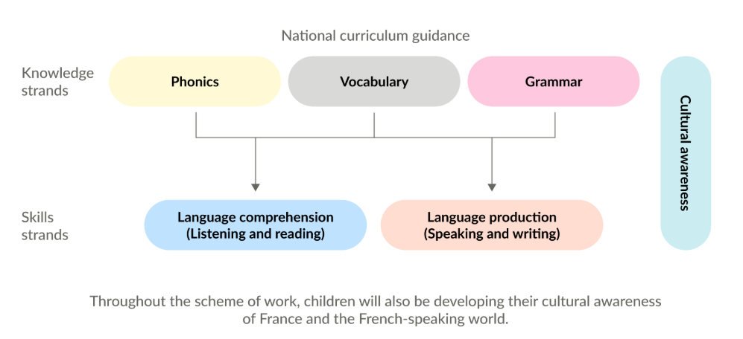

Progression
Our MFL curriculum is a spiral curriculum that builds on previous skills and revisits skills frequently to reactivate and embed learning and with the following key principles in mind. The progression of skills can be found on the KAPW portal.

- Cyclical – pupils revisit key knowledge and skills in different contexts, as well as familiar themes such as ‘All about me’, ‘Daily life’ and ‘France and other French-speaking countries’.
- Increasing depth – each time a vocabulary and grammatical structures are revisited, they are covered with greater complexity.
- Prior knowledge – prior knowledge is utilised so pupils can build upon previous foundations rather than starting again.

This approach reinforces knowledge and skills, supporting long-term retention and progression. New learning is weighted in years 3 and 4.
As a result, pupils are equipped to think like linguists: understanding how language works; communicating with increasing confidence and accuracy; and making connections between Spanish and their own language to deepen both linguistic and cultural understanding.

Inclusion and diversity
The scheme supports SMSC (Spiritual, Moral, Social and Cultural) development by encouraging children to:
- Explore different perspectives.
- Reflect on ethical issues.
- Collaborate with others.
- Appreciate cultural diversity through subject-specific content.

Kapow Primary’s French scheme has been designed to represent a wide range of cultures, communities and perspectives from across the French-speaking world.
- Where appropriate, the historical and cultural influences on the French language and its global presence are explored.
- The scheme’s visual and textual content is inclusive and representative of diverse people and places, challenging stereotypes and outdated views of French-speaking cultures.
- Within sensitive units, questions have been included to support children’s lived experiences and backgrounds.

The Kapow Primary French scheme supports children in appreciating the richness of the French language, the diversity of cultures where it is spoken, and the connections between different communities around the world.

Implementation
Timetabling
MFL is timetabled weekly in Key Stage 2 for 40 minutes. In order to achieve the recommended 45 minutes per week, staff are expected to take opportunities reinforce and practice orally the week’s learning and new vocabulary daily with the children.

CPD
The Kapow scheme of work includes teacher videos for each unit. This ensures the teachers have a thorough understanding of the knowledge, skills, key concepts and best practice to ensure effective implementation of the curriculum. With MFL this is particularly useful for ensuring correct pronunciation to used. Further opportunities for CPD and support are provided by the school’s subject lead and leadership team as appropriate.

Unit Structure
Within the KAPOW curriculum, there are key documents to support the teaching of each unit, such as the Progression of skills and knowledge and vocabulary progression, teaching videos and presentation guides.
Opportunities to activate prior learning and cross-curricular links are included within each unit.

Lesson structure
Lessons are structured to ensure all pupils are able to access the learning and succeed.
Recap and recall: Each lesson begins with a short activity revisiting prior learning. This helps reinforce key knowledge, activate long-term memory and create connections between past and new learning. Recap and recall activities are varied to keep the start of the lesson engaging and fun while still supporting active recall.
Attention grabber: A short, engaging activity designed to hook pupils into the new learning in the lesson. The activity could be a thought-provoking question, a quick investigation or an interactive discussion to spark curiosity and enthusiasm for the topic.
Main event: The core part of the lesson, where children engage in activities that develop their understanding of the learning objective. The Main event usually includes a mixture of teacher modelling, guided practice and independent or collaborative tasks tailored to support all learners.
Wrapping up: A final reflective activity that consolidates learning. Wrapping up activities could involve reviewing the success criteria, discussing key learning or applying knowledge in a different context to assess understanding and encourage deeper thinking.

Inclusion and SEND
Our curriculum is designed to be fully adaptable for pupils with SEND. Every lesson includes an adaptive teaching section, providing clear guidance on how activities can be modified to meet the needs of all learners.
Children learn in a variety of ways. Art lessons include a range of strategies to support and challenge every pupil, such as:

- Scaffolding – activities are designed with flexibility in mind, allowing for additional support or challenge where needed.
- Multi-sensory approaches – lessons incorporate different elements to engage all learners.
- Clear instructions and structured tasks – ensuring clarity and reducing cognitive load.
- Opportunities for collaborative and independent learning – allowing pupils to work at their own pace while building confidence and independence.
- Adaptive teaching embedded throughout, the scheme ensures that all pupils, regardless of their starting points, can access and succeed in their learning.
- The step-by-step curriculum design supports pupils with SEND, avoiding sudden jumps in complexity at transition points and allowing for steady, manageable progression.

IMPACT
Formative: Assessment throughout the lesson
Formative assessment is embedded throughout our curriculum to ensure that teachers can gauge pupils’ understanding in real time and adapt their teaching accordingly.
- Questioning – lesson plans include targeted and open-ended questions to check understanding, promote critical thinking and address misconceptions.
- Observation – teachers are supported to observe pupils during tasks, noting how they approach activities, collaborate and apply Art and design skills.
- Discussion and peer interaction – pair and group discussions are built into lessons, providing opportunities for pupils to articulate their thinking and for teachers to assess understanding through dialogue.
- Lesson pauses – plans include strategic pause points for checking comprehension, summarising learning and addressing any common errors before progressing.
- Retrieval practice – recap activities such as short recall tasks and oral explanations are embedded to reinforce prior knowledge and assess retention.
- Use of success criteria – success criteria are shared within lessons, allowing pupils to self-assess or peer-assess their work and reflect on their progress.
- Short reflections in the Wrapping up – lessons end with brief written or verbal reflections, enabling pupils to consolidate learning and teachers to gauge understanding.

Summative: Summative assessment opportunities
Each unit of work assesses children’s understanding and retention of key knowledge using an Assessment quiz with multiple-choice and open-ended questions.

Depending on the needs of the cohort, quiz questions may be read aloud and completed in small groups or as a whole-class activity, rather than being completed independently. Assessment quizzes provide teachers with a record of summative assessment – evidence of pupil progression throughout the year between key stages.
There is also a knowledge catcher which staff can use at their discretion to support teacher assessment judgements.
This evidence is then used by teachers to assess the pupils against the national curriculum descriptors for art and design at the end of each unit. This is added to our Insight assessment tracker.

Evidencing progress
Insight is used to track progress.
The children’s responses in lessons whether written, oral, photographic and creative are used as evidence of progress.
The children’s MFL books, show progress as it builds up over time, evidence that is collected are added to these.

 | Autumn A | Autumn B | Spring A | Spring B | Summer A | Summer B
Year 3 /4  Cycle A  2026-27 | French Greetings with Puppets  4 lessons  Using puppets to introduce a variety of greetings and to be able to introduce themselves.  - Look carefully at a speaker and respond confidently with the appropriate gesture and phrase.  -Begin to recognise how some sounds (‘on’, ‘ou’, ‘et’ and ‘oi’) are represented in written form.  -Link actions or pictures to the new vocabulary, both in spoken and written form.  -Imitate the pronunciation of sounds, taking turns to speak using appropriate intonation. | French adjectives of colour, size and shape  5 lessons  -Listen carefully to instructions to build correct sequences of three to four colour blocks.  -Show their understanding by correctly identifying a described shape, drawing it in the air or pointing on the board.  -Recognise cognates, finding shapes that they are asked for.  -Use please and thank you.  -Describe some of the shapes in their work using language of colour, size or shape.  -Correctly select a decoration described to them by its colour.  -Use software to produce artwork in the style of Matisse. | Playground games (numbers and age)  5 lessons  -Recall the numbers one to six in French, with generally accurate pronunciation, in particular vowel and combination sounds (‘un’, ‘eu’, ‘oi’, and ‘in’).  -Join in with a song using actions.  -Respond to numbers by showing fingers or ticking on whiteboards.  -Ask and answer a question about their age.  -Recognise number words.  -Listen carefully and relate sounds to written phonemes.  -Recall numbers one to twelve with increasingly accurate pronunciation. | In a French classroom  5 lessons  -Show their understanding of key vocabulary with a physical response.  -Attempt to accurately imitate the pronunciation of vocabulary.  -Correctly identify masculine and feminine nouns in written form.  -Use modelled language to create questions or sentences using appropriate articles.  -Deduce the meaning of new words, matching labels to pictures using a range of language detective skills.  -Attempt to build their own sentences using a label as a model.  -Speak clearly and present simple phrases when supported visually.  -Use appropriate intonation/ | Bon Appetit (Food)  5 lessons  Recognise which nouns are cognates or near cognates.  Explain ways to work out the meaning of unfamiliar words.  Identify the correct definite article for the names of fruit according to gender.  Correctly identify and pronounce plural nouns.  Accurately express an opinion with j’aime and je n’aime pas.  Say the numbers to 31 in French.  Read and calculate maths sums correctly in French.  Say and write all the days of the week.  Identify the days for yesterday and today.  Accurately perform a role play with good pronunciation and understanding. | Shopping for French food  5 lessons  -Recognise and explain how to build 2-digit numbers in words up to 60, using a number builder resource for support if needed.  -Listen carefully and make good attempts at accurate pronunciation of new vocabulary.  -Recognise how a sentence changes according to noun gender.  -Make predictions about language from a familiar story and join in with an oral performance.  -Use strategies to support recall of vocabulary.  -Make at least one change to a noun in a given sentence and present the sentence orally.  -Produce a short written story with some modelling and with some elements changed.
Year 3/ 4  Cycle B  2027-28 | This is me  4 lessons  -Recognise and respond to different greetings.  -Recognise and sound out phonemes and begin to notice key phonemes in French words.  -Form phrases to say hello and introduce themselves.  -Begin to recognise how some sounds are represented in written form.  -Ask someone how they are feeling and say how they are feeling.  -Relate written captions to image | School Days  5 lessons  -Deduce the meaning of new words using a range of language detective skills.  -Accurately imitate the pronunciation of new vocabulary, showing awareness of how accents change the sound.  -Speak clearly and present simple phrases using a visual support.  -Explain what there is and is not in a classroom.  -Correctly identify masculine and feminine nouns in written form.  -Extract key information from a written text.  -Use modelled language to create sentences containing appropriate articles.  -Write familiar language with a degree of accuracy by applying knowledge of sound-spelling links. | Birthday celebrations  5 lessons  -Say the numbers 1-31 in French.  -Read and calculate Maths sums correctly.  -Match French months to their English equivalents.  -Ask when someone’s birthday is and say when their birthday is.  -Compare similarities and differences between birthdays in the UK and France.  -Write sentences to create a wish list, describing things orally and in writing.  -Appreciate songs in the language.  -Compare French festivals and their traditions with English ones. | Colourful creatures  5 lessons  -Notice cognates and near-cognates.  -Use a dictionary to research the meaning of relevant vocabulary.  -Recognise and sort nouns by gender, and explain the effect this may have on an adjective.  -Recognise rules of agreement.  -Select the correct form of an adjective to ensure it agrees with the noun it describes.  -Use appropriate words and phrases to adapt model sentences.  -Identify similarities and differences between word order in French and English. | Fabulous French food  5 lessons  -Broaden their vocabulary and develop their ability to understand new words that are introduced into familiar written material, including through using a dictionary.  -Use the indefinite articles un and une correctly.  -Speak in sentences, using familiar vocabulary, phrases and basic language structures.  -Present ideas and information orally to a range of audience.  -Read carefully and show understanding of words, phrases and simple writing.  -Show understanding of spoken language by joining in and responding.  -Apply language detective strategies to decode the meaning of new words.  -Adapt a written model | Shopping for French Food  5 lessons  -Recognise and explain how to build 2-digit numbers in words up to 60, using a number builder resource for support if needed.  -Listen carefully and make good attempts at accurate pronunciation of new vocabulary.  - Recognise how a sentence changes according to noun gender.  -Make predictions about language from a familiar story and join in with an oral performance.  -Use strategies to support recall of vocabulary.  -Make at least one change to a noun in a given sentence and present the sentence orally.  -Produce a short written story with some modelling and with some elements changed.

