Shillington Lower School Pupil premium strategy statement

This statement details our school’s use of pupil premium funding to help improve the attainment of our disadvantaged pupils.
It outlines our pupil premium strategy, how we intend to spend the funding in this academic year and the outcomes for disadvantaged pupils last academic year (2023-2024).

School overview
Detail | Data
Number of pupils in school | 82
Proportion (%) of pupil premium eligible pupils | 17%
Academic year/years that our current pupil premium strategy plan covers (3-year plans are recommended – you must still publish an updated statement each academic year) | 2024-2027  (2025-2026)
Date this statement was published | December 2025
Date on which it will be reviewed | September 2026
Statement authorised by | Sarah Woodham
Pupil premium lead | Ciara Dumpleton
Governor / Trustee lead | Donna Jones

Funding overview
Detail | Amount
Pupil premium funding allocation this academic year | £ 18,559 estimated
Pupil premium funding carried forward from previous years (enter £0 if not applicable) | £0
Total budget for this academic year | £18,559  estimated

Part A: Pupil premium strategy plan

Statement of intent
We believe in maximising the use of the Pupil Premium Grant by developing a long-term strategy aligned to the School Development Plan priorities, coupled with excellent knowledge of our children. Our intention is that all children, irrespective of their background or the challenges they face, make good progress and achieve high attainment across all subject areas. The focus of our pupil premium strategy is to support disadvantaged children to achieve that goal, including progress for those who are already high attainers.
Our carefully planned Pupil Premium Strategy provides targeted support to all disadvantaged children, identifying potential barriers to learning and enabling them to fulfil the same goals as non-disadvantaged children. In addition to children identified as disadvantaged, we also consider the wider needs of potentially vulnerable children and identify greatest need across the school e.g. those who have a Social Worker or whose current circumstances may be, in our professional opinion, proving to be a barrier to education.
Our approach is rooted in research and is evidence based. It draws upon principles of the RADY (Raising the Attainment of Disadvantaged Youngsters) approach to close gaps between our disadvantaged children and their peers both in terms of attainment and holistic opportunities and experiences through focusing on equity not equality.
Ensuring high quality first teaching for all children is at the heart of our whole school. To focus on closing any attainment gaps identified, interventions specific to the needs of the child are used. This combination is proven to have the most significant impact on closing attainments gaps and will therefore benefit disadvantaged and non-disadvantaged children. Interventions are reviewed regularly to enable us to measure their impact and continue to be responsive and challenge appropriately. Regular assessments enable us to ensure that our support is based on individual needs and not assumptions about the impact of disadvantage.
All staff are aware of their role and responsibility for disadvantaged children’s outcomes and are continually striving to raise expectations of what they can achieve.

Challenges
This details the key challenges to achievement that we have identified among our disadvantaged pupils.
Challenge number | Detail of challenge
1 | Attainment  Data analysis, book looks and observations indicate that the overall attainment and progress of disadvantaged children is generally lower than that of their non-disadvantaged peers in reading and maths and significantly lower in writing.
2 | Additional needs  A number of our disadvantaged children also have additional needs such as SEND and safeguarding concerns. This results in many of these children often struggling with basic concepts and requiring additional support/provision/services in order to raise achievement.  2022-2023: 30%  2023-2024: 43%  2024-2025: 58%  2025-2026: 64%
3 | Language skills & Vocabulary  Assessments, observations, and discussions with pupils indicate underdeveloped oral language skills and vocabulary gaps which are more prevalent among our disadvantaged children than their peers. This impacts on social and communication skills as well as their phonics, reading and writing.
4 | Phonics and Early reading  Assessments of phonics knowledge and observations of pupils’ phonic skills indicate that disadvantaged children are more likely to require support in order to confidently use phonics to decode. This negatively impacts their development as readers and as such, impacts on them successfully accessing the planned curriculum.
5 | SEMH & Wellbeing  Our assessments observations and discussions with children and families have identified a range of behavioural, social, and emotional needs. These challenges particularly affect our disadvantaged children. They and their families are requiring higher levels of support for the effects of attachment and trauma, with some children finding it difficult to regulate their emotions, or internalising them. This impacts on their emotional wellbeing, self-esteem and in turn, their learning and the learning of others. These needs can result in difficult detrimental behaviour and dangerous detrimental behaviour.  57% children at Shillington Lower of whom are disadvantaged currently require additional support with behaviour, social and emotional needs.
6 | Attendance  Monitoring of attendance data shows that disadvantaged children’s attendance is less than good. Research indicates that absenteeism negatively affects all pupil’s progress inclusive of disadvantaged pupils.
7 | Low cultural capital  Some of our children have limited access to extra-curricular activities and  find it difficult to pay for educational visits, extra-curricular clubs and  sports/music tuition. This results in a lack of a breadth of experiences that enable disadvantaged children to contextualise their learning and broaden their opportunities.
8 | Parental engagement  Some of our families show a lower level of parental engagement. This reduces the opportunities for communication between the school and home to re-affirm the value of education and related expectations to provide support as necessary.

Intended outcomes
This explains the outcomes we are aiming for by the end of our current strategy plan, and how we will measure whether they have been achieved.
Intended outcome | Success criteria
Attainment  Disadvantaged children who do not have a SEND need, to achieve strong outcomes at the end of the academic year and make accelerated progress to diminish the gap between them and their non PP peers. | - High quality teaching leads to improved outcomes for PP and non PP children.  - Through interventions, gaps in PP children’s knowledge and understanding are reduced.  - Outcomes show that all gaps have closed/reduced between PP and non-PP children in reading, writing and maths in each year group.  - Higher percentage of children reach age related expectations in Reading, Writing and Maths.  - Children achieve the expected standard in the Year 1 & 2 phonics check and Year 4 Multiplication check
Additional Needs  The needs of disadvantaged children with additional barriers to their learning are addressed and access appropriate, evidence-based, highly effective provisions and/or external services in order to make accelerated progress towards their individual targets | - Monitoring and analysis of provisions and external services being used/accessed indicate that all are effective. This is evident when triangulated with other sources of evidence, including engagement in lessons, book scrutiny and on-going formative assessment.  - Children make at least expected progress from their starting points.
Language skills & vocabulary  Achieve and sustain improved vocabulary and oral language among disadvantaged pupils across the school. | - Children’s written and oral work demonstrates an improved ability to use and understand explicitly taught tier 2 and 3 vocabulary.  - Children use explicitly taught vocabulary when talking about their learning. They know more and remember more.
Phonics and Early reading  High quality teaching of ELS phonics and interventions shows PP children making progress and an increase in PP children passing the phonics screening check in year 1. | - Half termly phonics assessments and analysis identify children who required interventions.  - Children make progress throughout the year with their phonics learning and achieve the expected standard in the Yr1 phonics screening check.
SEMH & Wellbeing  Children’s basic, emotional and mental health needs are being met ensuring readiness for learning, high levels of self-esteem and greater levels of emotional resilience | - PP children to have access to social and emotional support, at the level that is required for each individual, to ensure they are able to learn.  - Relevant interventions show impact through positive engagement in learning and children’s attitudes.  - External counselling and play therapist providing support for identified children  - Therapeutic thinking principles are incorporated into key policies
Attendance  Improved attendance of PP children | - There will be a reduction in the absenteeism levels for PP children  - Overall attendance % for all children being no less than 96%, and the attendance gap between disadvantaged children and their non-disadvantaged peers narrows.  - Poor attendance will be challenged through the use of letters, meetings with parents, support where needed, and action plans.
Low cultural capital  Children have access to high quality cultural capital experiences in line with non PP peers to develop the whole child and have access to the same life experiences as their peers. | - There will be an equitable approach to supporting our disadvantaged children across the whole curriculum and in regards to cultural capital  - There will be proportional representation of disadvantaged children in opportunities across the school such as school council, sports ambassadors, extra-curricular clubs, music lessons etc.

Activity in this academic year
This details how we intend to spend our pupil premium funding this academic year to address the challenges listed above.

Teaching (for example, CPD, recruitment and retention)
Budgeted cost: £ 6495
Activity | Evidence that supports this approach | Challenge number(s) addressed
Develop staff expertise in adaptive teaching through targeted CPD ensuring inclusive practice that enables disadvantaged pupils to access and succeed across the curriculum | - EEF Guide to the Pupil Premium (2025): High-quality teaching is the single most important lever schools have to improve outcomes for disadvantaged pupils. Adaptive teaching, tailoring instruction to pupils’ needs is highlighted as central to effective use of Pupil Premium funding.  - EEF blog: Five-a-day for pupils with SEND – a cluster of adaptive approaches  - EEF blog: Moving from ​‘differentiation’ to ​‘adaptive teaching’  - Adaptive Teaching and the Ofsted Toolkit (2025): Ofsted now expects schools to demonstrate how teaching is adapted “in the moment” to ensure disadvantaged pupils and those with SEND can access the full curriculum. This marks a shift from static differentiation to responsive, inclusive teaching. | 1,2
CBC KS1 Training Programme for class teachers and subject leaders to strengthen pedagogy in writing, reading, and maths, with a particular focus on inclusivity for children experiencing socio-economic disadvantage.  Release time for class teachers/subject leads to attend sessions | - Central Bedfordshire’s attainment outcomes are among the lowest in the region, as shown in local authority performance data published by Central Bedfordshire Council and the DfE. This challenge is particularly evident in writing, where disadvantaged pupils are disproportionately affected. Our own school data reflects this regional picture, with writing outcomes for disadvantaged pupils significantly below those of their peers.  - The EEF Guidance Report on Effective Professional Development shows that sustained, subject-specific CPD (such as multi-session programmes) has greater impact than one-off training.  - The Writing Framework highlights the importance of systematic teaching of handwriting, spelling, and sentence structure, alongside fostering motivation and self-efficacy in writing.  - The EEF Improving Mathematics in Eary years and Key Stage 1 report evidences that mastery approaches, use of manipulatives, and scaffolding are effective in supporting disadvantaged pupils.  - Evidence indicates that High-Quality Teaching (EEF) is the most effective way to support disadvantaged pupils, ensuring they benefit first from strong classroom practice before additional interventions. | 1,2
Ongoing training for staff on Therapeutic Thinking Approach to Behaviour  Management and use of de-escalation strategies | - Therapeutic Thinking is a school-based approach to behaviour that focuses on the emotional and mental health of children and young people. It was developed by Angela Wadham, a child behaviour professional. Its philosophy focuses on supporting children's emotional wellbeing and mental health. It develops an understanding of responding to children who may communicate through their behaviours.  EEF Guidance Report improving behaviour in schools  - The Timpson Review of School Exclusion finds children eligible for free school meals (FSM) are four times more likely to be permanently excluded than their peers. Therapeutic Thinking programmes have reported significant reductions in exclusions after adoption, directly benefiting disadvantaged pupils. | 2,5
Ongoing CPD to improve phonics teaching and reading across the school.  Subject leader  release time to  coach and monitor | EFF Phonics states that phonics has a positive impact overall (+5 months) with very extensive evidence and is an important component in the development of early reading skills, particularly for children from disadvantaged backgrounds.  The Reading Framework | 1,4
Develop oral language skills and vocabulary using high quality texts, modelling and challenging vocabulary. High quality talk and discussion across whole curriculum to develop oracy and vocabulary enabling children to articulate key ideas, consolidate understanding and extend vocabulary. | - Oxford Language Report indicates that over half of those surveyed (>1300) reported that at least 40% of their pupils lacked the vocabulary to access their learning. 69% of primary school teachers believe the word gap is increasing.’  - ‘Why closing the words gap matters’ 2018  - Studies of oral language interventions consistently show positive benefits on learning, including oral language skills and reading comprehension  - The EEF ‘Preparing for Literacy’ states that we should ‘Prioritise the development of communication and language’  - ‘The EEF toolkit suggests that oral language interventions which include – targeted reading aloud and discussing books with young children, explicitly extending pupils’ spoken vocabulary and the use of structured questioning to develop reading comprehension can improve outcomes by up to 5 months.  EEF Oral Language Interventions | 1,3

Targeted academic support (for example, tutoring, one-to-one support, structured interventions)
Budgeted cost: £9280
Activity | Evidence that supports this approach | Challenge number(s) addressed
Targeted Interventions  including speech and  language, phonics, reading, writing and maths to improve outcomes to narrow the gap between disadvantaged and others in school. | - EEF evidence consistently shows the positive impact that targeted academic support can have, including for those pupils who are not making good progress across the spectrum of achievement.  - EEF research which focuses on teaching assistants who provide one to one or small group targeted interventions shows a positive benefit of between four and six additional months on average. Often interventions are based on a clearly specified approach which teaching assistants have been trained to deliver.  - Oral language interventions can have a positive impact on pupils’ language skills. EEF results of large-scale effectiveness trial indicates +4 months. Oral language interventions | Toolkit Strand | Education Endowment Foundation | EEF  - Phonics approaches have a strong evidence base indicating a positive impact on pupils, particularly from disadvantaged backgrounds. Targeted phonics interventions have been shown to be more effective when delivered as regular sessions over a period up to 12 weeks:  - Phonics | Toolkit Strand | Education Endowment Foundation | EEF  - EEF small group tuition +4 months  - EEF HLTA/teaching assistant interventions +4 months  1:1 tuition/small group work and personalised learning results in a +5 months gain EEF | 1-5
To invest in online learning programmes such as TT Rock Stars, Numbots and Spelling shed. | EEF Research has identified remedial and tutorial use of technology as being particularly practical for lower attaining pupils, those with special educational needs or those from disadvantaged backgrounds in providing intensive support to enable them to catch up with their peers. Technology can be particularly useful in personalising learning to match pupils’ individual abilities and needs given the potential for such programmes to adapt and focus on the child’s learning needs. | 1,2,8

Wider strategies (for example, related to attendance, behaviour, wellbeing)
Budgeted cost: £ 2784
Activity | Evidence that supports this approach | Challenge number(s) addressed
Embed  Zones of Regulation enabling children to build resilience, understand and communicate emotions and embrace their mental and emotional wellbeing. | - The EEFs Improving Social and Emotional learning in Primary Schools report stresses this is especially important for children from disadvantaged backgrounds and other vulnerable groups, who, on average, have weaker SEL skills at all ages than their non-disadvantaged peers. These skills are likely to influence a range of outcomes for pupils. Lower social and emotional skills are linked to poorer mental health and lower academic attainment.  Evidence from the EEF’s Teaching and Learning Toolkit suggests that effective SEL can lead to learning gains of +4 months over the course of a year. | 1,2,5
Implement a behaviour curriculum for children, explicitly teaching values, expectations, and strategies for self-regulation and positive interactions. | - EEF Guidance Report: Improving Behaviour in Schools  - Recommends that schools explicitly teach learning behaviours alongside managing misbehaviour. It highlights the importance of consistent whole-school routines and clear expectations to reduce disruption and improve outcomes. It also recognises that misbehaviour negatively impacts pupil attainment, particularly for disadvantaged pupils | 5
Use of play therapist/ Hamish and Milo sessions/ NHS Health and Wellbeing coach to support Mental Health and Social and Emotional issues | - We want to support the children’s social emotional needs alongside their learning needs which is recognised in the DfE Supporting the attainment of disadvantaged pupils. Successful schools have strong social and emotional support strategies to help pupils in need of additional support, including through working with their families.  - NFER suggests that in order to support children’s learning, emotional support needs to be provided to address any underlying issues. On average, social and emotional interventions have an identifiable and significant impact on attitudes to learning, social relationships in school, and attainment itself (four months' additional progress on average) according to the EFF Toolkit.  EEF Social and emotional learning (SEL) interventions +4 months  - They also state that, ‘SEL programmes appear to benefit disadvantaged or low-attaining pupils more than other pupils, though all pupils benefit on average  - ’EEF Self-regulation strategies +3 months  - Hamish & Milo is based on attachment theory, human development and the neuroscience of relationships in early social and emotional development, as well as understanding the impact of emotional stress on the developing child.  - Emerging data shows statistically significant differences in observations about the emotional and behavioural presentation of children, pre and post intervention.  Evidence-based SEMH programmes | 1,2,5
Provide practical strategies to support learning at home through phonics, reading, writing and maths workshops | The EEF ‘Preparing for Literacy’ states ‘Promising strategies include encouraging parents to read to children before they can read, then to begin reading with children as soon as they can; and running workshops showing parents how to read and talk about books with their children effectively.’  ‘Working with Parents to Support Children’s Learning’  - EEF – parental engagement +3 months approaches and programmes which aim to develop parental skills such as literacy or IT skills; general approaches which encourage parents to support their children with, for example reading or homework; the involvement of parents in their children’s learning activities; and more intensive programmes for families in crisis. | 1,2, 4,8
Support parental engagement by ensuring all parents attend parent consultations, as well as opportunities to participate in school activities where they can such as curriculum workshops. Use of Seesaw to engage parents with children’s learning. Teachers to monitor and support parents of pupil premium children,  using Seesaw. | Parental engagement has a positive impact on average of 4 months’ additional progress. Approaches and programmes which aim to develop parental skills such as literacy or IT skills; general approaches which encourage parents to support their children with, for example reading or homework; the involvement of parents in their children’s learning activities; and more intensive programmes for families in crisis. | 1,4,8
Increased participation in opportunities across the school such as school council, sports ambassadors, extra-curricular clubs, music lessons etc. | EEF evidence indicates that when pupils take pride and engage in wider aspects of school life socially, they achieve well as they are more settled. | 1,5,7
Building cultural capital though clubs, activities, trips and experiences – providing subsidised funding as appropriate to ensure all eligible children are able to benefit from activities and experiences on offer | Parent voice has shown that this has been popular and an effective strategy.  • The life experiences of some children are limited. Enrichment is a pathway to engagement, aspiration and therefore raised attainment. Exposure to a wider range of experience will enhance vocabulary, knowledge and enjoyment of learning.  • In the past there has been a positive effect on soft outcomes for children across the schools including an improvement in a growth mindset and self-confidence. We do not want any of our children to be disadvantaged because of financial circumstances | 1,5,7
To continue to monitor attendance and work with parents to ensure this is high for disadvantaged children.  Embedding principles of good practice set out in the DfE’s Working Together to improve school attendance | It is widely acknowledged that regular monitoring and analysis of attendance data can ensure that intervention is delivered quickly to address absences. Research shows that disadvantaged children are significantly more likely to be persistent absentees.  Clear evidenced link between attendance and attainment. NfER briefing for school leaders identifies addressing attendance as a key step. | 1,2,6,8
Contingency fund to purchase equipment to support children’s  ability to make progress  against their  individual targets. | Where children have been identified as having specific need, we will take our ‘evidence’ from the  recommendations of external professionals e.g. Educational  Psychologists, SEN Team, Jigsaw, Virtual Schools etc. | 1,2,

Total budgeted cost: £18,559 estimated
NB – This strategy sits alongside other identified funding streams e.g. SEND budget which complement each other and provide a comprehensive programme of support and intervention for our children

Part B: Review of the previous academic year
This details the impact that our pupil premium activity had on pupils in the 2024 to 2025 academic year.
Intended outcome

Attainment
Disadvantaged children who do not have a SEND need, to achieve strong outcomes at the end of the academic year and make accelerated progress to diminish the gap between them and their non PP peers.
Outcome
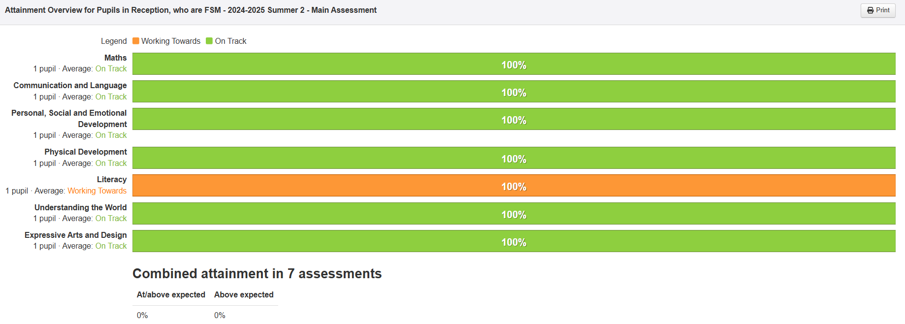
EYFS PPG without SEND attainment

EYFS non PPG without SEND attainment
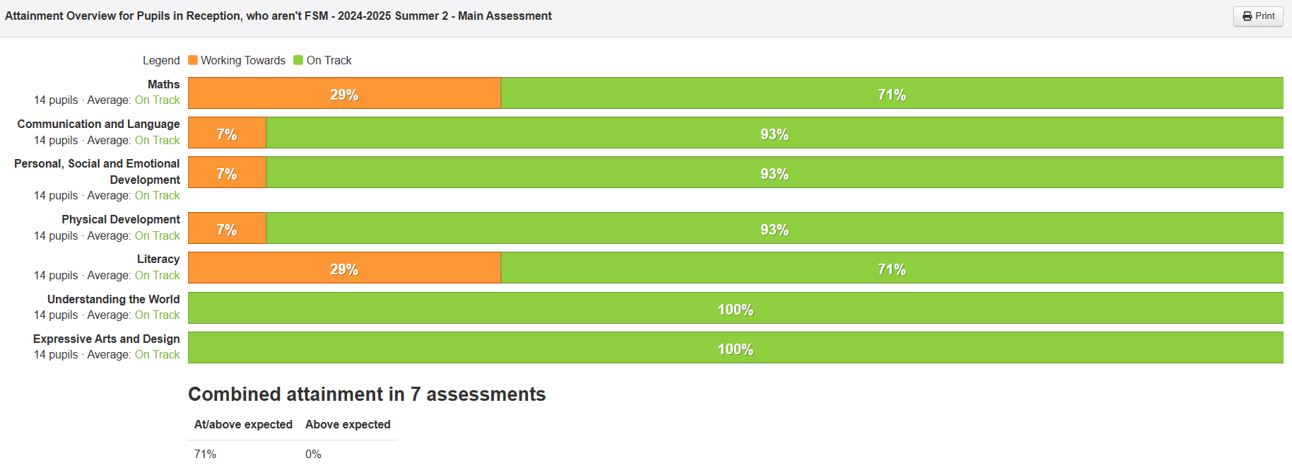
EYFS PPG child without SEND achieved ELGs in 6 out of the 7 areas except Literacy. Although the child did not meet the ELG in literacy, they made expected progress from their starting point (see below) in this area. This reflects the effectiveness of targeted support and Quality First Teaching. The child's progress indicates solid foundations for continued learning in Key Stage 1.
EYFS PPG without SEND Progress
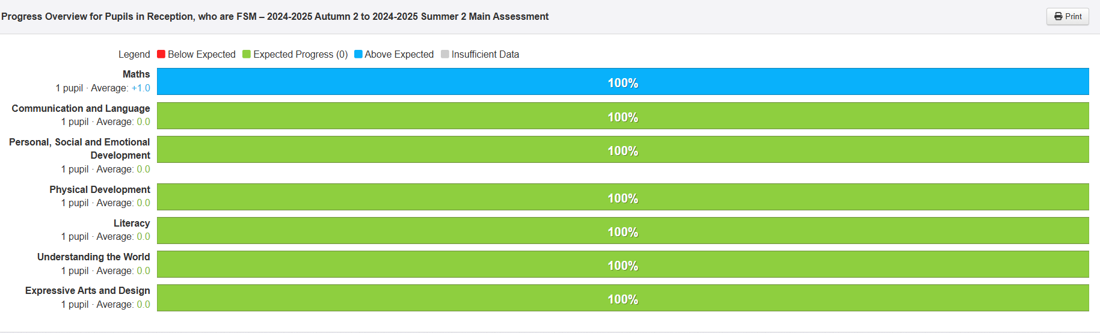
Yr 1-4 PPG without SEND attainment
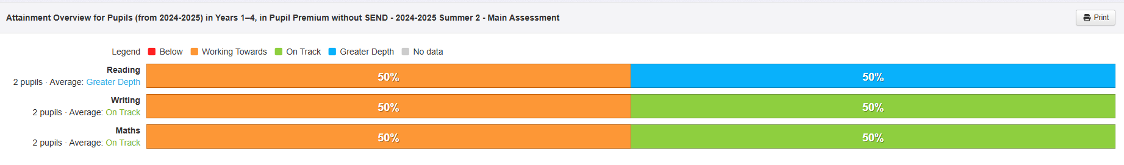
Yr 1-4 Non PPG without SEND attainment
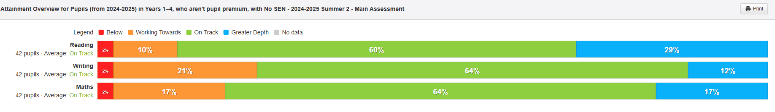
Yr 1-4 PPG children without SEND progress
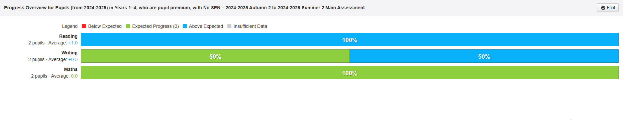
Yr 1-4 Non PPG children without SEND progress
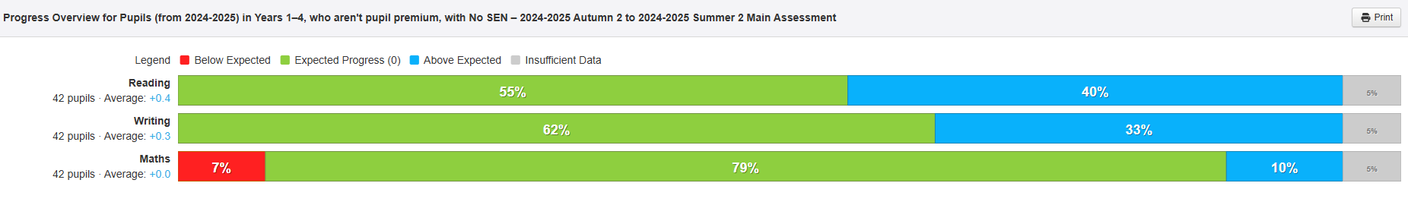
50% of PPG children without identified SEND met age related expectations (exceeding in maths) by the end of the year. Although the remaining 50% did not achieve age related expectations they demonstrated sustained progress, with evidence of either expected or above expected progress from their individual starting points. This indicates that while attainment remains a target area, progress measures reflect the positive impact of targeted support. Further work is needed to accelerate progress and close the attainment gap with non-PP peers.

Phonics Screening
There were no PPG children without SEND in year 1 who took the screening
50% PPG children without SEND passed the Yr 2 phonics retake screening check. The other child made good progress from their Yr 1 result.

Yr 4 MTC
There were no PPG children without SEND who participated in the Multiplication Tables Check (MTC) this year; therefore, no MTC data is available for this group
Attainment
To ensure that the needs of disadvantaged children with additional barriers to their learning are addressed. Children make at least expected progress from their starting points.
Outcome
At the end of 2024-25, 73% of our disadvantaged children are also on the SEN register.

PPG EYFS children (with SEND) attainment
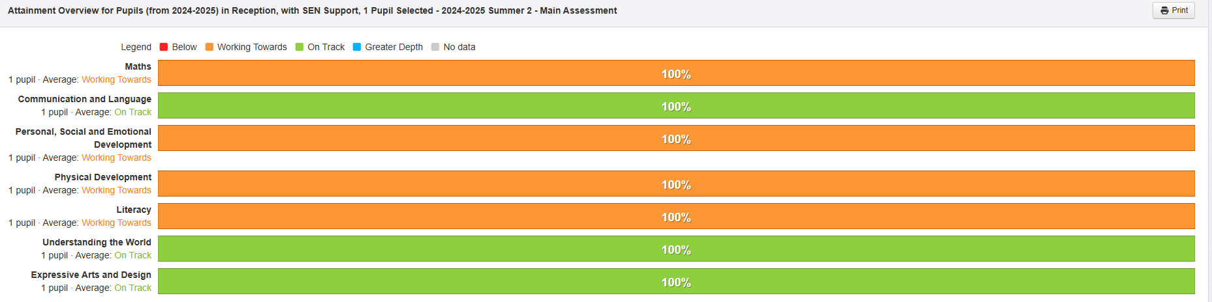
Non PPG EYFS children (with SEND) attainment
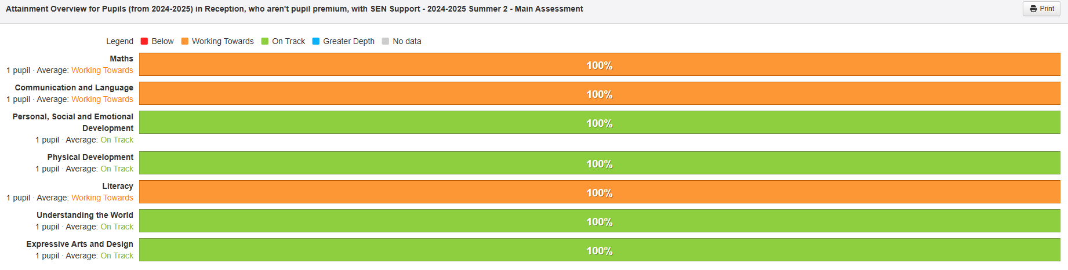

PPG EYFS children (with SEND) progress
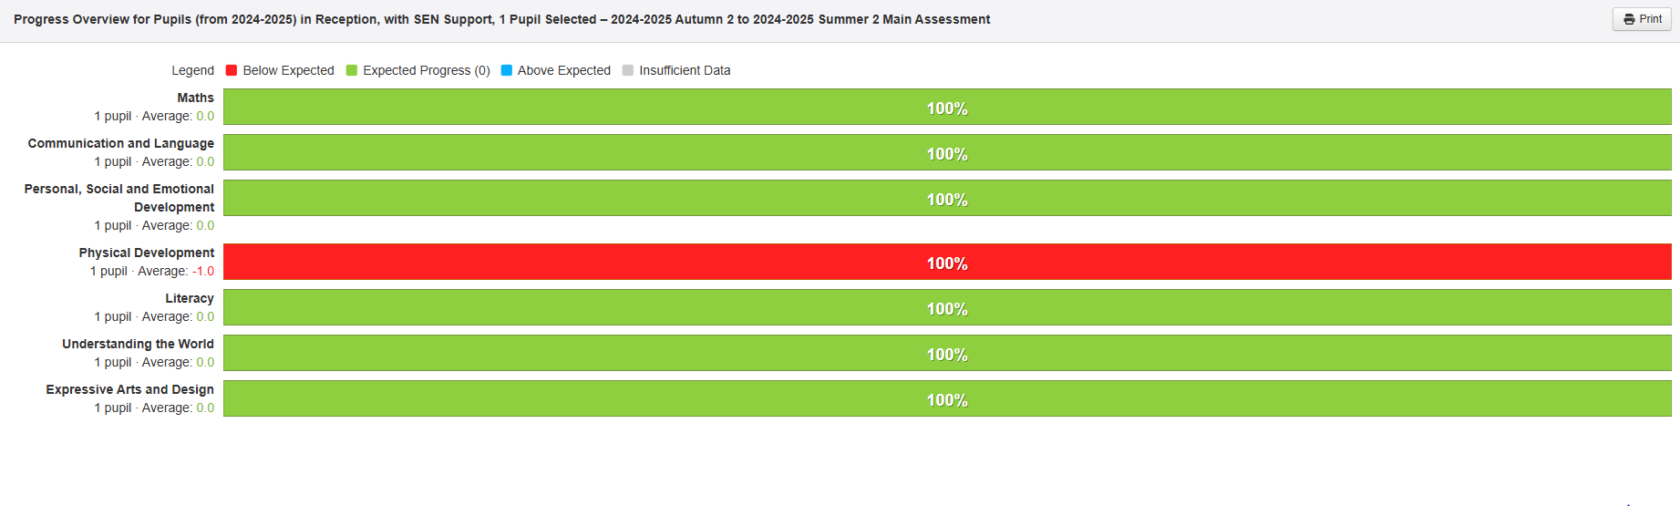

Non PPG EYFS children (with SEND) progress
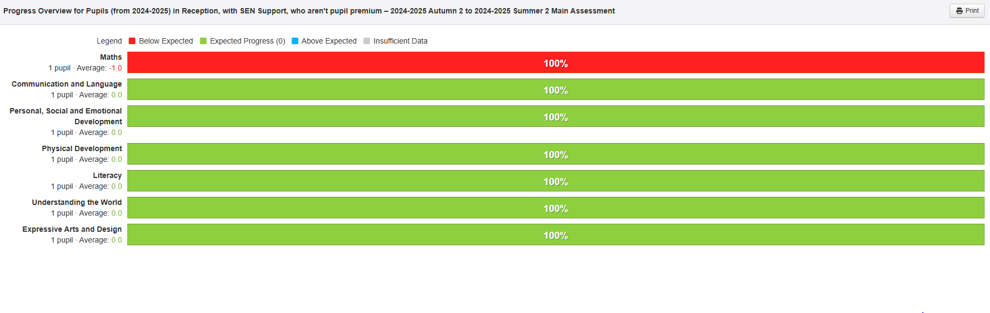Attainment and progress broadly in line for these two groups. Neither group achieved GLD but made the expected progress in all but 1 area.
Yr 1-4 PPG children with SEND attainment

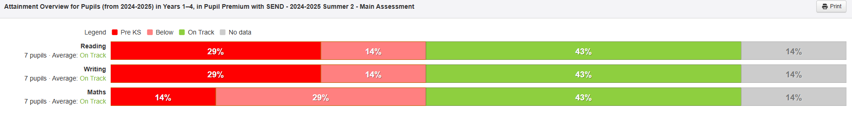

Yr 1- 4 Non PPG children with SEND

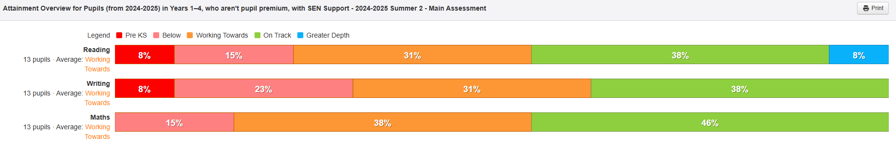
Yr 1-4 PPG children (with SEND) progress
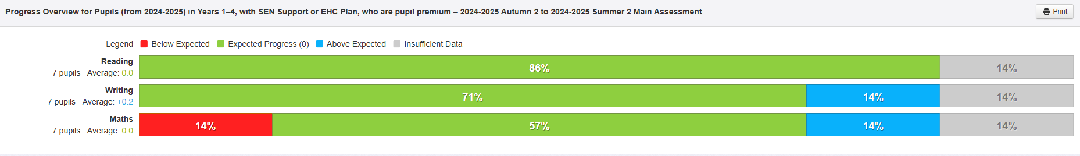

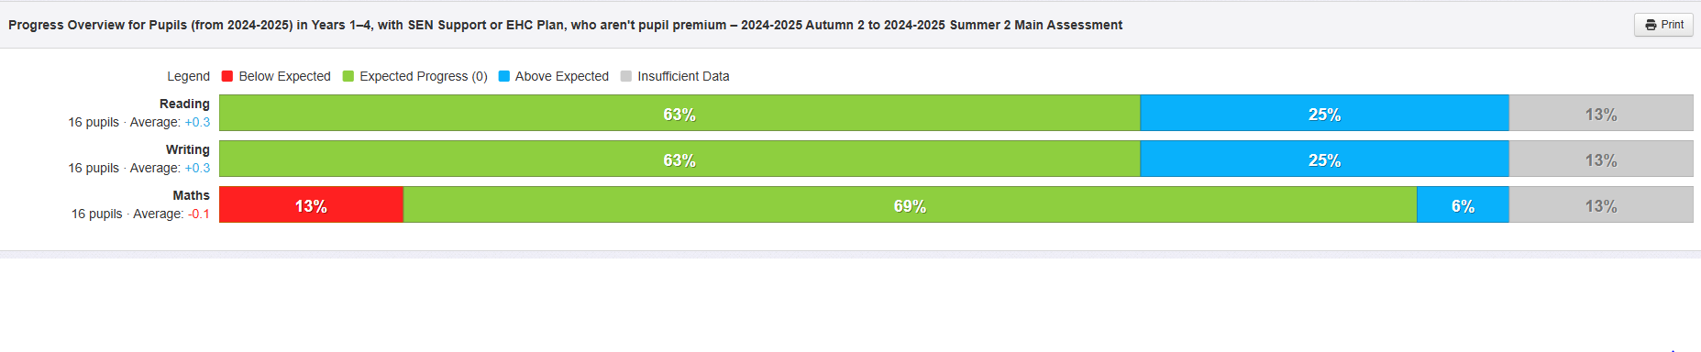
Yr 1-4 Non PPG children (with SEND) progress
The attainment and progress of PPG children with SEND is broadly comparable to their non-PPG SEND peers across subjects. Despite additional barriers, a proportionally similar number of disadvantaged learners are reaching expected standards, which suggests effective targeting of support.

Yr 1 Phonics Screening
Of the children with identified SEND, one child in Year 1 successfully passed the phonics screening check. Two other children, retaking the check in Year 2, did not achieve the pass mark but made progress from Year 1 scores.
Yr 4 MTC
A Pupil Premium child in Year 4, with SEND was not working at the expected standard for the Multiplication Tables Check (MTC) and did not take part in the assessment. As such, no MTC attainment data is available for this group.
Intended outcome | Outcome
Quality First Teaching  CPD opportunities are provided for all staff to refresh and strengthen practice.  To ensure longer term learning for our disadvantaged children by using a range of strategies to help ‘make learning stick’ so that children know more and remember more.  Gaps in knowledge and understanding will be identified and addressed through adapting the curriculum, frequent low stakes testing/retrieval practice and spaced practiced to develop long term memory. | In subjects that are well developed and teachers have received training, pupils remember what they have learned well. Pupils make connections with other learning experiences and remember more. In subjects not as well developed, not all pupils remember what they have been taught. OFSTED July 2023.  Teachers are more explicit when making links to new learning so that children make connections to prior learning.  Children’s understanding of how they learn and draw on strategies/engage in strategies which enables the learning to ‘stick’ needs to continue to be a focus so that children independently regulate their own learning, knowing which strategies are a strength for them and identifying which areas they need to improve.
SEMH & Well being  Children’s basic, emotional and mental health needs are being met ensuring readiness for learning, high levels of self-esteem and greater levels of emotional resilience | By the end of 2024–25, 89% of our PPG children have experienced Adverse Childhood Experiences which has impacted on their emotional and mental health. All staff have been trained in Therapeutic Thinking during the year. All these children have access to enhanced classroom SEMH support delivered by Teaching Assistants. This approach has contributed to fewer behaviour incidents among these children, improved engagement with learning, and increased emotional resilience.
Cultural Capital  Children have access to high quality cultural capital experiences in line with non PP peers to develop the whole child and have access to the same life experiences as their peers. | All PPG children have participated in opportunities across the school such as school council, sports ambassadors and extra-curricular clubs. They have had the opportunity to perform to varying sized audiences including performing at the O2 arena in London.  Fully or part funded educational visits/ residential trip to enhance their learning, have enabled all PPG to have the same experiences as their non PP peers and social economic gap is reduced.
Language skills & vocabulary  Improvement in children’s early language and communication development is prioritised in EYFS and KS1 which lead to improvements in KS2. | 100% of PPG children achieved ELGs in Language and Communication.  Improving levels of oracy, increased confidence in communication and use of wider breadth of exposure to vocabulary is evident.  Key vocabulary is identified for each subject which is learnt, displayed and used by staff and children. This will continue to remain a focus.  Support staff are being upskilled to deliver SALT interventions.
Parental engagement & attendance  Parents are well supported to meet all the needs of their children both academically, socially and emotionally. | 2023-2024 whole school attendance: 93.5%  2024 PPG attendance: 88.9%  (National 89%)  Over all school attendance 2024-2025 93.1%  PPG Children attendance 2024-2025 - 92.76%  Individual absences which fell below 96% were monitored and discussed with the attendance officer.  Regular communication with parents regarding their children's learning is shared through Seesaw and school newsletters. All PPG families have access to Seesaw, providing consistent updates, targeted resources, and direct communication with staff. Engagement with these platforms is actively monitored to identify families requiring additional support, ensuring PPG children’s needs are identified and addressed promptly.  The school has adapted its approach to parent engagement to better meet the needs of our families. Rather than relying on in-person workshops, digital resources such as phonics session recordings and guidance materials have been shared with parents. This allows parents to access valuable learning content at their convenience, removing barriers associated with scheduled, in-person sessions. This format enables continued engagement without the need to attend at specific times, while also providing a lasting resource that can be revisited when needed.  Full attendance at parent consultations was achieved through prompt follow-up of missed appointments and offering flexible rescheduling, ensuring all families remained engaged in their child’s progress.

Externally provided programmes
Please include the names of any non-DfE programmes that you used your pupil premium to fund in the previous academic year.
Programme | Provider
Times Tables Rock stars | Maths Circle Ltd
Spelling Shed | Education Shed Ltd

